CURRICULUM VITAE
BAGUS HARLIANTO TAKENGON S.E. | MANAGEMENT

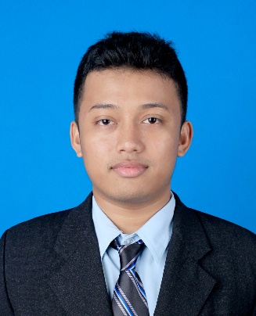 | Address  JL. RH Abdul Halim RT 01/ RW 19 No. 83 Sukanampa  Cimahi  40522  Phone  0822-4034-5022  E-mail  bagusharliantotakengon  @gmail.com |  | CERTIFICATE  TOEFL | (2019)  SOFTWARE | (2016)  BREVET PAJAK | (2014)  EXPERIENCE  STAFF ADMIN COLLECTION | (2017)  PT. SUKANDA DJAYA  COLLATERAL STAFF | (2017 – 2021)  ADIRA FINANCE  EDUCATION  University of Computer Indonesia  (2012 – 2016)  FINANCIAL MANAGEMENT  1 Pasundan Senior High School  (2007 – 2010)  SCIENCE  5 PGRI Junior High School  (2004 – 2007)  Sindangsari Elementary School  (1998 – 2004)  LANGUAGE  INDONESIA  ENGLISH  SUNDANASE

PERSONAL IDENTITY

Date of birth : Bandung, 22 April 1992
Gender : Male
Status : Single
Religion : Moslem
Hight / Weight : 165cm / 63kg
IPK : 3.17

PERSONAL SKILLS

TEAM WORK
CREATIVITY
COMMUNICATION
PHOTOGRAPHY
SOCIAL

PROFESSIONAL SKILLS

MS. OFFICE
PHOTOSHOP

